**Introduction**

This paper discusses a framework for evaluating and optimizing a risk-based portfolio of risky assets such that the relative performance (e.g. Sharpe ratio) of each of the portfolio components is close to the overall portfolio's relative performance. Risk-based, instead of forecasting-based, portfolios are chosen to forego the pitfalls of the latter method. The first section of the paper provides an introduction. The second section provides a general framework for the problem and chooses the measures in the applied optimization. The third section addresses the optimization process and the effects of estimation error. The fourth section discusses a simple allocation example across 6 asset classes and the associated in sample and out of sample performance.

**Framework**

The general framework explains variables used in the optimization and important properties of those variables. The number of assets (components) is given by the variable $N$. The weight (position) vector of the portfolio components is given by $w$. $w^{*}$ is the optimal weight of a reference portfolio and $\hat{w}$ is the optimal weight of a PRCC-optimized portfolio. Portfolio performance, risk and relative performance are respectively given by $P_{p}\left(w\right), R_{p}\left(w\right) and τ_{p}^{P,R}(w)$. Performance and risk are required to be first order homogeneous functions so these properties hold:

$P_{p}(bw)=bP_{p}(w)$ and $P_{p}\left(w\right)=\sum_{i=1}^{N}{w_{i}\frac{∂P_{p}(w)}{∂w_{i}}}$

$R_{p}(bw)=bR_{p}(w)$ and $R_{p}\left(w\right)=\sum_{i=1}^{N}{w_{i}\frac{∂R_{p}(w)}{∂w_{i}}}$ where $b>0$.

Each component's contribution to portfolio performance and risk is as follows:

$C_{i}^{P}\left(w\right)=w_{i}\frac{∂P_{p}(w)}{∂w_{i}}$ and $C_{i}^{R}\left(w\right)=w_{i}\frac{∂R_{p}(w)}{∂w_{i}}$

Each component's performance/risk contribution (i.e. relative performance contribution) is as follows:

$${CPRC}_{i}\left(w\right)=C_{i}^{p}(w)-τ_{P}^{P,R}(w){*C}_{i}^{R}(w)$$

The focus of the paper is the performance/risk contribution concentration which is an aggregate measure of the dispersion in balance between all pairs of CPRCs.

$$PRCC\left(w\right)=\frac{1}{2N^{2}}\sum_{i=1}^{N}{\sum_{j=1}^{N}{{[{CPRC}_{i}(w)-{CPRC}_{j}(w)]}^{2}}}=\frac{1}{N}\sum_{i=1}^{N}{{{CPRC}_{i}(w)}^{2}}$$

The smallest PRCC is 0, which indicates that every position has a CPRC=0. In other words, every position has the same relative performance as the portfolio. Larger PRCC values indicate that certain positions are either overly contributing to (higher return or lower risk) or overly detracting from (lower return or higher risk) the portfolio's relative performance.

In the applied setting, the following measures are used. $μ$ is the vector of expected arithmetic returns. $\tilde{μ}$ is the vector of expected excess return over the risk free rate. $Σ_{nxn}$ is the covariance matrix of arithmetic returns. These 3 are estimated by the respective sample estimates. Portfolio performance is the portfolio mean excess expected return, risk is the portfolio volatility (standard deviation) and relative performance is the Sharpe ratio.

$P_{p}\left(w\right)={\tilde{μ}}_{p}\left(w\right)=w^{T}\tilde{μ}$ and $R_{p}\left(w\right)=σ_{p}\left(w\right)=\sqrt{w^{T}Σw}$ and $τ_{p}^{P,R}\left(w\right)=τ_{p}^{\tilde{μ},σ}\left(w\right)=\frac{{\tilde{μ}}_{p}\left(w\right)}{σ_{p}\left(w\right)}$

The performance and risk are both first degree homogeneous so each component's contribution to performance and risk is as follows:

$C_{i}^{P}\left(w\right)=C_{i}^{\tilde{μ}}\left(w\right)=w_{i}{\tilde{μ}}_{i}$ and $C_{i}^{R}\left(w\right)=C_{i}^{σ}\left(w\right)=w_{i}\frac{{[Σw]}_{i}}{σ_{p}\left(w\right)}$

**PRCC-Optimization Process**

PRCC-Optimization is actually the second optimization in a two-step optimization process. The first optimization finds the optimal weights $w^{*}$ and relative performance (e.g. Sharpe ratio) $τ_{p}^{*}$ of a long-only reference portfolio according to a portfolio rule. The paper uses the following five portfolio rules: minimum variance, inverse volatility, equally weighted, equal risk contribution and maximum diversification (see Appendix 1). A maximum Sharpe ratio portfolio is also considered, but PRCC-optimization is not carried out on this portfolio since the PRCC of this portfolio is 0.

PRCC-optimization finds the optimal weights $\hat{w}$ according to the following program:

$$\hat{w}={argmin}_{w}PRCC\left(w\right) s.t. τ_{p}^{P,R}=τ_{p}^{*} , \frac{1}{N}\sum_{i=1}^{N}{{(w_{i}-w_{i}^{*})}^{2}≤δ^{2} , w^{T}1=1 , 0≤w_{i}≤1 }$$

In words, the program seeks to tilt $w^{*}$ in a direction such that each component's relative performance is closer to the portfolio's relative performance (though the experiments in the following sections show this isn't always the case). The sum of squared weight differences is a tracking error constraint. $δ$ is set at 10%. The constraints are imposed to keep the portfolio long-only and to limit the impact of potential estimation error in excess returns. An analytical solution is not given and since the tracking error is a quadratic function, the program is optimized using sequential quadratic programming, starting at $w^{*}$.

**Effects of Estimation Error**

The goal of this section is to evaluate the impact of mean excess return estimation error on the weights and performance of the maximum Sharpe and five PRCC-optimized portfolios. Ultimately, the analysis shows that PRCC-optimized portfolios are robust to estimation error and that estimation error has a greater effect on weights than performance.

The analysis in this section follows the process of Best and Grauter (1991). Six portfolio rules (given in the previous paragraph), a ten asset universe (not detailed in this paper), and six perturbations $kϵ\{0.5, 0.75, 1.25, 1.5, 1.75, 2\}$ performed separately on each asset's mean excess return are applied in the analysis. The experimental process is as follows:

1. $w^{*}$ is calculated once for the maximum Sharpe portfolio under no estimation error assumption.
2. $\hat{w}$ is calculated for the maximum Sharpe portfolio under each of the perturbation assumptions applied separately to each asset. This yields 10 scenarios under each perturbation; 60 total.
3. $w^{*}$ is calculated for the five PRCC-optimized portfolios under no estimation error assumption.
4. $\hat{w}$ is calculated for each of the five PRCC-optimized portfolios under each of the perturbation assumptions applied separately to each asset. This yields 10 scenarios under each of the 6 perturbations for each of the 5 portfolio rules; 300 total.
5. Four weight metrics are calculated for each scenario and are given as follows: mean absolute deviation (MAD) $\overline{|\hat{w}-w^{*}|}$, $\#\{{\hat{w}}_{i}<0.1\%\}$, $max⁡\{{\hat{w}}_{i}\}$ and normalized Herfindahl index $H(\hat{w})$. The worst case among the ten assets per each of the six portfolio rules per each of the six perturbations are reported in the paper.
6. Four performance ratio metrics are calculated for each scenario and are given as follows: ${{\tilde{μ}}_{p}\left(\hat{w}\right)}/{{\tilde{μ}}_{p}\left(w^{*}\right)}$, ${σ_{p}\left(\hat{w}\right)}/{σ_{p}\left(w^{*}\right)}$, ${τ_{p}(\hat{w})}/{τ_{p}(w^{*})}$ and $PRCC(\hat{w})$. The worst case among the ten assets per each of the six portfolio rules per each of the six perturbations are reported.

These metrics are self explanatory (or previously explained) except for the normalized Herfindahl index $H\left(w\right)={(\sum_{i=1}^{N}{{\hat{w}}_{i}^{2}}-1/N)}/{(1-1/N)}$. This metric, ranging from 0 to 1, indicates the extent to which $w$ is dominated by individual elements. Typically, the metric is used to indicate competition among firms in an industry.

See Appendix 2 for the experiment results. The maximum Sharpe portfolio weights are greatly affected by estimation error. It has the greatest MAD, $\max\left\{{\hat{w}}_{i}\right\}$ and Herfindahl index. The MAD ranges from 5.18% (k=.75) to 14.68% (k=2) while the smallest and largest MADs are all within 3% for the PRCC-optimized portfolios. The $max⁡\{{\hat{w}}_{i}\}$ ranges from 33.26% (k=1, no perturbation) to 88.11% (k=2), with the other portfolios all having a smaller range. The Herfindahl index ranges from 0.1 (k=1) to 0.76 (k=2). The PRCC-optimized minimum variance portfolio also has a large Herfindahl range of 0.13 to 0.53, but the others are within 0.1.So, the PRCC-optimized weights are generally robust to mean excess return estimation error, particularly relative to the maximum Sharpe portfolio.

Overall, the performance ratios of all of the portfolios are fairly robust to estimation error. They typically range between 0.9 and 1.1, indicating that the performance metrics for the error less and assumed error optimizations are within 10% of each other. For the maximum Sharpe ratio portfolio, the relative performance ratio $τ_{p}$ decreases to 0.83 as k increases, but this is not a huge change. Also, the PRCC increases with k, indicating the estimation error forces at least one of the components' relative performances to deviate from the portfolio's relative performance. The PRCC-optimized equally weighted portfolio's ${\hat{μ}}_{p}$ and $σ_{p}$ ratios both decrease to 0.83 and 0.74 respectively as k increases. This uneven decrease pushes the $τ_{p}$ ratio to 1.13 as k increases, but this isn't far outside of the 10% range. The PRCC-optimized portfolio PRCCs typically remain close to or below 0.1. A few deviate higher, such as the PRCC-optimized maximum diversification portfolio at .35 for k=1.75, but decrease for higher k.

**Data**

One goal in the paper is to apply PRCC optimization to a real world scenario. In practice, a large universe of assets are considered, but for simplicity, the data here are simplified to indexes on six asset classes: developed market equity, emerging market equity, US government bonds, US corporate investment grade bonds, real estate and gold. The indexes are respectively: MSCI World Total Return Index, MSCI Emerging Markets Index, Bloomberg US Government Bond 1-10 Year Index, BofA Merrill Lynch US Corp Master Total Return Index, All REITS Total Index (NAREIT) and Gold Fixing Price at 3 P.M. London time in the London Bullion Market. The risk free rate is the one month treasury bill. The index values are end of month USD and range from 01/1988 - 08/2015.

**In Sample Performance and Analysis**

Using all of the data, calculate $w^{*}$ and $τ_{p}^{*}$ for each of the five reference portfolios. Using $w^{*}$ and $τ_{p}^{*}$, calculate $\hat{w}$ for the PRCC-optimized portfolios for each of the five reference portfolios. For each of the ten portfolios, calculate annualized statistics using $w=w^{* }or w=\hat{w}$ where applicable.

${\hat{μ}}_{p}\left(w\right)=12w^{T}\hat{μ}$, $σ_{p}\left(w\right)=\sqrt{12w^{T}Σw}$, $τ_{p}^{\hat{μ},σ}\left(w\right)={{\hat{μ}}_{p}\left(w\right)}/{σ_{p}\left(w\right)}$

$$PRCC\left(w\right)=12\frac{1}{N}\sum_{i=1}^{N}{{{CPRC}_{i}(w)}^{2}}$$

For each $w_{i}$ in each portfolio, calculate annualized statistics:

$C_{i}^{\tilde{μ}}\left(w\right)=12w_{i}{\tilde{μ}}_{i}$, $C_{i}^{σ}\left(w\right)=\sqrt{12}w_{i}\frac{{\left[Σw\right]}_{i}}{σ_{p}\left(w\right)}$

$${CPRC}_{i}\left(w\right)=C_{i}^{\hat{μ}}\left(w\right)-({\sum_{j=1}^{N}{C_{j}^{\hat{μ}}\left(w\right)}}/{\sum_{j=1}^{N}{C_{j}^{σ}\left(w\right)}}){*C}_{i}^{σ}(w)$$

For the PRCC-optimized portfolios, calculate the tracking error: $\frac{1}{N}\sum_{i=1}^{N}{{({\hat{w}}_{i}-w_{i}^{*})}^{2} }$

See Appendix 3 for the experiment results. For the benchmark reference portfolios, US government bond weight dominates all portfolios (except for equally weighted of course). This is due to its high Sharpe ratio and low volatility, which these portfolio rules favor. Interestingly however, PRCC-optimization for three portfolios has a noticeable effect (15%+ change) on the weights for that asset. For example, PRCC-optimized maximum diversification portfolio favors an even larger weighting towards US government bonds. PRCC-optimization for the equally weighted portfolio strongly favors NAREIT, increasing its weighting from 16% to 32%. Naturally, the equally weighted portfolio has the highest mean return and volatility due to its heavier weighting in the more volatile and higher return assets. The minimum variance portfolio is almost PRCC optimal (i.e. PRCC = 0) even before PRCC-optimization. In all cases, PRCC-optimization decreases PRCC, but notice that the tracking error (TE) constraint is binding at 10% in three cases, indicating that further PRCC reduction is possible if this constraint is loosened.

**Out of Sample Performance and Analysis**

The out of sample experiment more closely mimics a real world application. Eleven portfolios are evaluated: five reference portfolios, five PRCC-optimized portfolios and a benchmark max Sharpe portfolio. All of the portfolios are rebalanced monthly with a 36 month rolling window. For example, optimal weights $w^{* }and \hat{w}$ for the month of 01/1991 for each portfolio are calculated using data from the period 01/1988 to 12/1990. Ultimately, 296 monthly observations are realized.

Using optimal weights and the realized returns for each index for each month, monthly portfolio returns are calculated for each portfolio. The following statistics are used to evaluate the results: cumulative return of $1, annualized geometric return (including risk free rate), mean/standard deviation/skewness/kurtosis/5% modified VaR of excess returns and mean tracking error for PRCC-optimized portfolios. Modified VaR uses the Cornish-Fisher expansion to approximate quantiles.

See Appendix 4 for the experiment results. An important result is that for this sample, PRCC-optimization increased the cumulative return (and geometric return) in all cases. While this is not the explicit goal of PRCC-optimization, it is an important consideration for typical investors. It also increased the mean return in all cases, but only decreased the standard deviation for the equally weighted portfolio. The Sharpe ratio decreased slightly for the minimum variance portfolio but increased for the others. Among the other metrics, there is no universal benefit to applying PRCC-optimization. Some portfolios improved for some of these metrics while others degraded. Interestingly, the max Sharpe ratio portfolio does not have the largest Sharpe ratio. This is due to estimation error, as discussed previously. The average tracking error is >9% (on a 10% constraint) for the inverse volatility, equally weighted and equal risk contribution portfolios, indicating that PRCC-optimization tended to greatly change the weights for these portfolios, at least relative to the other two PRCC-optimizations.

**Replication Study of In Sample and Out of Sample Performance**

All of the required data were found except for the Bloomberg US Government Bond 1-10 Year Index, and a suitable substitute could not be found for the required dates. The in sample and out of sample replications were performed on the available data using Python's SciPy Optimization library. Since the optimizations are all long only (i.e. weight constraints greater than or equal to 0), no analytical solution exists for the optimizations thus the requirement of a software optimization package. An interesting issue encountered was that the PRCC value was on the order of 10^-8 which was below the optimization tolerance. This issue was corrected by multiplying the PRCC by 1 billion and confirmed by the fact that the optimal PRCC was in fact lower than the reference portfolio's PRCC without violating any constraints.

The results of the in sample replication are in Appendix 5. Due to the missing US government bond asset, it is difficult to compare the replication with the original. In all cases, PRCC-optimization increased the portfolio mean, and of course the standard deviation also increased since the Sharpe ratio is fixed. The minimum variance portfolio is the least affected by PRCC-optimization, like in the original. The equally weighted portfolio is highly affected in the replication, favoring NAREIT even more so than in the original and activating the tracking error constraint at 10%. It's also noticeable that the three portfolios that activated the tracking error constraint in the original were far from activating it in the replication. A good conclusion drawn from these results is that the US government bond, with its relatively higher Sharpe ratio, has a strong affect on reference and PRCC portfolio optimizations.

The results of the out of sample replication are in Appendix 6. Here, the most striking difference between the replication and original is the cumulative return and geometric return values both before and after PRCC-optimization. It might be expected that the replication should have higher values here since US government bonds have relatively lower returns than the other asset classes. There could of course be calculation errors or different calculations used. In the replication, PRCC-optimization decreased the cumulative return of the equally weighted portfolio, whereas it increased the cumulative return in all other cases (it increased the cumulative return in all cases in the original). The average tracking errors are all lower indicating that on average, PRCC-optimization did not move the weights as much as in the original. The maximum Sharpe ratio portfolio also doesn't have the maximum Sharpe ratio, again due to estimation error.

**Conclusion and Further Analysis**

This paper, for the most part, takes a basic approach to portfolio optimization with respect to the metrics employed. Mean and volatility are standard metrics, but the novel approach, at least to me, is the PRCC since I had not heard of or considered the concept previously. The framework makes clear that other metrics could be employed for performance or risk, and the paper notes that when volatility is replaced by modified value-at-risk (in the web appendix) the conclusions drawn in the paper are not greatly affected. Expanding the universe of assets and considering the wide variety of portfolio performance and risk metrics are ideas for further analysis.

**Appendix 1 - Common Portfolio Rules**

The following are all subject to: $w_{i}≥0 for 1≤i≤N$ and $w^{T}\overset{⃑}{1}=1$

|  |  |
| --- | --- |
| *Minimum Variance Portfolio* | $$w^{*}={argmin}_{w}w^{T}Σw$$ |
| *Inverse Volatility Portfolio* | $w^{*}=\frac{ξ}{ξ^{T}\overset{⃑}{1}}$ with $ξ={(σ_{1}^{-1},…,σ_{N}^{-1})}^{T}$ |
| *Equally Weighted Portfolio* | $$w^{*}=\overset{⃑}{1}/N$$ |
| *Equal Risk Contribution Portfolio* | $$w^{*}={argmin}_{w}\sum_{i=1}^{N}{\sum_{j=1}^{N}{{[C_{i}^{σ}\left(w\right)-C_{j}^{σ}(w)]}^{2}}}$$ |
| *Maximum Diversification Portfolio* | $w^{*}={argmax}_{w}\frac{w^{T}\overset{⃑}{σ}}{\sqrt{w^{T}Σw}}$ with $\overset{⃑}{σ}={(σ_{1},…,σ_{N})}^{T}$ |
| *Maximum Sharpe Portfolio* | $w^{*}={argmax}_{w}\frac{w^{T}\overset{⃑}{μ}}{\sqrt{w^{T}Σw}}$ with $\overset{⃑}{μ}={(μ_{1},…,μ_{N})}^{T}$ |

**Appendix 2 - Results of Estimation Error Experiment**

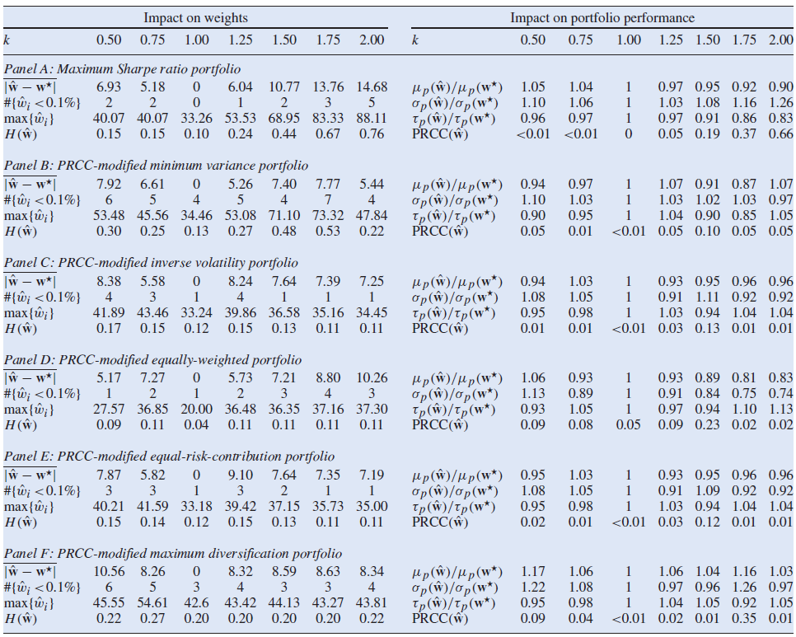

**Appendix 3 - Results of In Sample Experiment**

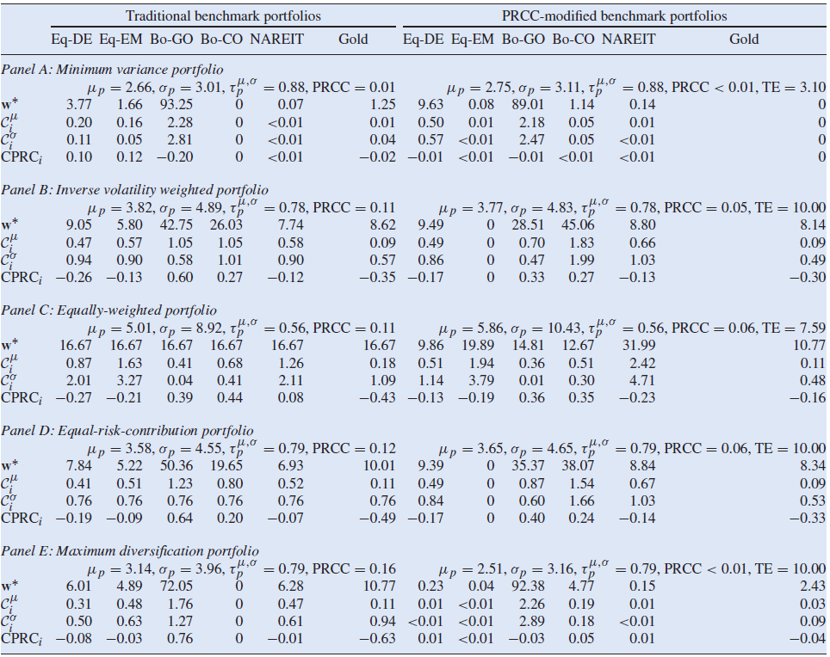

**Appendix 4 - Results of Out of Sample Experiment**

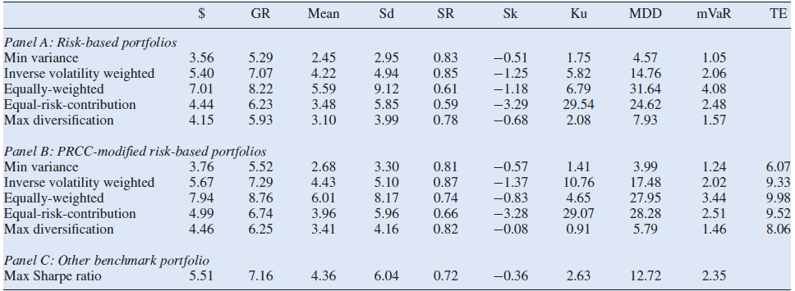

**Appendix 5 - Replication In Sample Experiment**

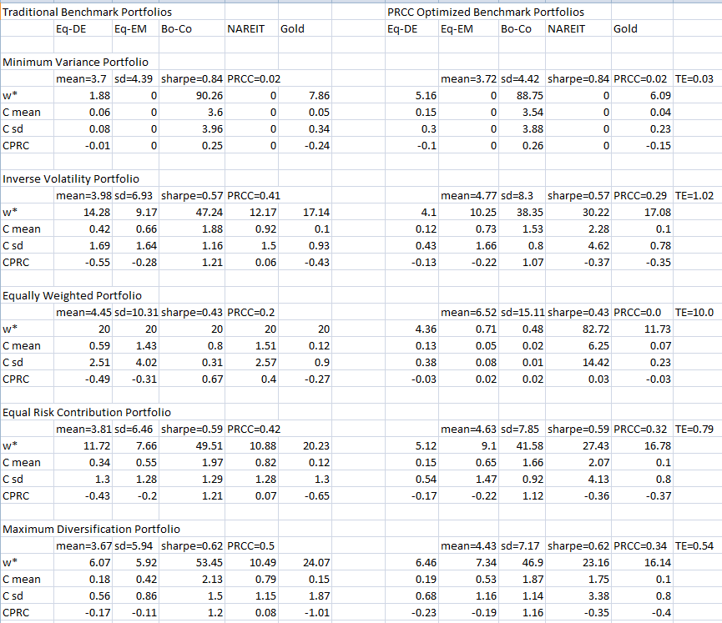

**Appendix 6 - Replication Out of Sample Experiment**

